République Algérienne Démocratique et Populaire Ministère de l’Enseignement Supérieur et de la Recherche Scientifique



ECOLE SUPERIEURE DE TECHNOLOGIE DE L’INFORMATIQUE ET DU NUMERIQUE



**Module: Project**



**Planning and Building a House Rental App**

**Case Study: Krelli**



#### Created By: Supervised by :

### Safi Achraf - MMe .Hamma

### Outerbah Mohamed - MMe .Makhloufi

### Laieb Mouad

### Benzada Mehdi

### Cherif Boumedien

### Foudi Mouhamed Islam

### Academic Year 2023/2024

**Contents :**

0. **General Introdution** 1

1. **Chapter 1:** Description And Project 2 Organization
   1. Introduction 6
   2. Project framework 6
   3. Problematic 7
   4. Study of existence and critiques 8
   5. Objectives of our project 9
   6. Methodology 10
      1. Agile Methodology 11
      2. Adopted Methodology 12
      3. Conclusion 13
   7. Expressions of needs 14
      1. Functional requirements 14
      2. Non-functional requirements 15
      3. Identification of audience 16
   8. Use case diagram 17
      1. Description 17
      2. System use case diagram 18
   9. Conclusion 19
2. **Chapter 2:** Conception 20
   1. Introduction 21
   2. Sequence diagram 21
      1. Description 21
      2. Sequence diagram of the system 22
   3. Class diagram 23
      1. Description 23
      2. Class diagram of the system 23
   4. Relational model of the database 25
   5. Conclusion 26

**General Introdution :**

The landscape of rental property is undergoing a digital revolution. Traditionally, finding a rental involved flipping through newspapers or relying on word-of-mouth recommendations. This often meant a tedious search process with limited options. Today, online platforms are streamlining the process for both renters and landlords, offering a more efficient and connected experience. Renters can browse a wider selection of properties with detailed descriptions, photos, and virtual tours, all at their fingertips. Landlords can connect with a wider pool of qualified tenants and manage their rental properties more effectively. This digital shift is transforming the way we approach renting, creating a more transparent and convenient experience for everyone involved.

As students passionate about technology and its potential to improve everyday life, we at ESTIN identified this growing trend in online rentals. Recognizing the unique needs of the Algerian rental market, we chose this challenge as the focus of our 2CP Project during our second semester. the development of Krelli, a web and mobile application designed to revolutionize the rental experience in Algeria. Krelli is our vision for a more efficient, user-friendly, and secure platform that connects renters with their dream homes and empowers landlords to manage their properties with ease.

***Chapter 1 :***

***Description and Project Organization***

**1.1 Introduction :**

This chapter provides a detailed overview of the app and website for renting houses that we will develop as part of our project. We will begin by presenting the project context and explaining the reasons for choosing to create a house rental platform. We will also discuss the objectives and benefits that we aim to achieve through this project. Next, we will describe the main features of the house rental app and website that we have developed, as well as the methodology adopted for the implementation of our system.

**1.2 Project framework :**

This project is undertaken within the framework of the project module in the second year of preparatory classes at the Higher School of Information Technology (ESTIN). Our objective is to develop a comprehensive web and mobile application tailored to the Algerian rental market. This application aims to provide users with an intuitive and seamless platform for finding, booking, and managing rental properties across Algeria.

The application will leverage the latest web and mobile technologies to ensure an optimal user experience. Key features will include a user-friendly interface, advanced search functionality, secure booking and payment systems, as well as comprehensive account management capabilities for both renters and landlords.

We have chosen to adopt an agile methodology for the development process, allowing for iterative improvements and close collaboration with stakeholders. This approach ensures flexibility and responsiveness to evolving user needs and market demands.

Additionally, rigorous testing will be conducted throughout the development lifecycle to ensure the application's reliability, security, and performance. Our goal is to deliver a high-quality product that enhances the rental experience for users in Algeria and lays the foundation for potential expansion into global markets in the future.

**1.3 Problematic :**

Every summer, Algeria faces a common challenge: a surge in the number of people actively searching for rental properties. The heightened demand during this season often leads to a competitive and time-consuming process for both renters and landlords. Recognizing this recurring issue, we aim to introduce a innovative rental application that streamlines the search process, providing a user-friendly platform for individuals seeking housing solutions and property owners looking to connect with prospective tenants. Our solution is to simplify and enhance the rental experience in Algeria, fostering a more efficient and satisfactory housing market for our community.

**1.4 Study of existence and critiques :**

While Krelli offers a streamlined and secure platform for finding your dream rental in Algeria, there are other options available, each with its own limitations:

**Facebook Marketplace:** While convenient for casual browsing, Facebook Marketplace can be cluttered with unreliable listings and lacks robust search filters specifically designed for rentals. Additionally, there's no guarantee of user verification, making it difficult to assess the legitimacy of landlords or renters.

**Ouedkniss:** A popular classifieds platform in Algeria, Ouedkniss can be overwhelming due to the sheer volume of listings, many of which may not be relevant to rentals. Verifying the accuracy and condition of properties advertised can be challenging, and secure payment options might be limited.

**Airbnb:** Primarily focused on short-term rentals and vacation stays, Airbnb isn't ideal for finding long-term rentals in Algeria. Rental agreements and tenant rights may not be clearly defined, potentially leading to confusion or disputes. Additionally, Airbnb fees can add a significant cost burden for both renters and landlords.

**1.5 Objectives of our project:**

In order to enhance the rental experience for users in Algeria, our project aims to provide innovative solutions through our web and mobile application. These solutions will add significant value to the rental process and better meet the expectations of our users by offering a seamless and intuitive rental experience. We will achieve this by:

**1. Creating a Comprehensive Rental Platform:**

Our platform will offer users a one-stop solution for finding, booking, and managing rental properties across Algeria. By providing a user-friendly interface and advanced search functionalities, we aim to simplify the rental process and make it more convenient for users.

**2. Enhancing Visibility and Accessibility:**

By offering a centralized platform for rental listings, we will increase the visibility of rental properties for both landlords and tenants. This will allow landlords to reach a wider audience of potential tenants and enable users to discover a diverse range of rental options conveniently.

**3. Improving User Experience:**

We are committed to providing an exceptional user experience by implementing features such as easy property browsing, secure booking and payment systems, and personalized account management. Our goal is to make the rental process enjoyable and hassle-free for users.

**4. Empowering Property Owners:**

Our platform will empower property owners by providing them with tools to effectively manage their listings, including options for updating property details, managing availability, and communicating with potential tenants. This will enable landlords to maximize the visibility and rental potential of their properties.

**5. Fostering Trust and Transparency:**

We understand the importance of trust and transparency in the rental process. Therefore, we will prioritize features that promote transparency, such as detailed property descriptions, accurate photos, and verified user reviews. This will build trust among users and enhance the credibility of our platform.

**6. Continuous Improvement and Adaptation:**

Our project will be developed using agile methodologies, allowing for iterative improvements and adaptations based on user feedback and market trends. We are committed to continuously enhancing our platform to meet the evolving needs of users in Algeria.

Through these objectives, we aim to create a rental platform that offers unparalleled convenience, reliability, and satisfaction for users in Algeria, ultimately contributing to the growth and development of the rental market in the region.

**1.6 - Methodology :**

The choice of methodology is crucial for the success of a project, because it has an impact on the way the project will be carried out. Therefore, the right choice leads to the successful completion of the project. To achieve this, there are several design methods available: the traditional waterfall approach, and different agile approaches such as mainly Scrum, eXtreme Programming (XP), and Kanban. Here is a comparative table of agile methodologies:

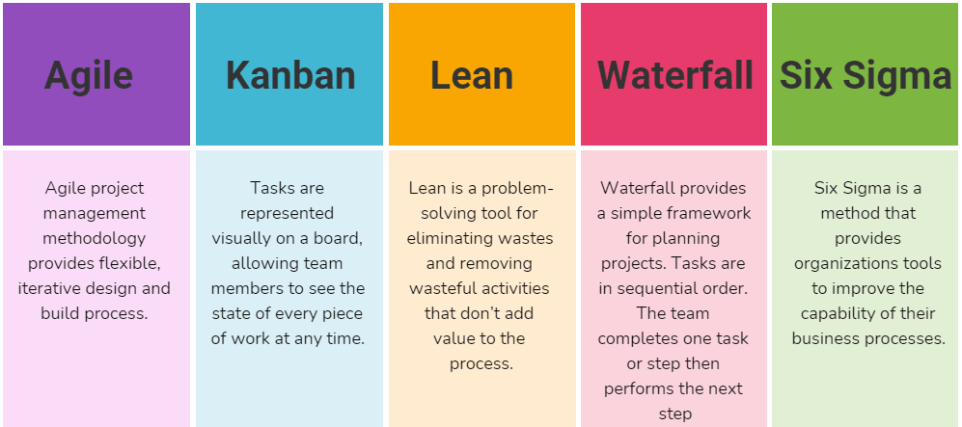

**1.6.1- Agile Methodology:**

An agile methodology is an iterative and collaborative approach that can take into account the initial needs of the client and those related to changes. The agile methodology is based on a development cycle that puts the client at the center to involve them in the realization from the beginning to the end of the project. This involvement allows the team to obtain regular feedback in order to directly apply the necessary changes. Thanks to the agile method, the client obtains better visibility of the work management than with a classic method. This method aims to accelerate the development of software. In addition, it ensures the realization of a functional software throughout the duration of its creation.

Key Features of Agile Methodology :

* **Iterative and incremental development:** The project is divided into small, manageable iterations. Each iteration is a complete development cycle, from requirements gathering to testing and deployment.
* **Collaboration and communication:** Agile methodologies emphasize collaboration and communication between all stakeholders, including the client, the development team, and the QA team.
* **Regular feedback and adaptation:** Agile methodologies encourage regular feedback from the client and other stakeholders. This feedback is used to adapt the project plan and to make changes to the product as needed.

**1.6.2- Kanban**

At Krelli, we understand the importance of choosing the right development methodology to ensure a successful and efficient project. After careful consideration, we've chosen the **Kanban** method to guide the development of our innovative Algerian rental app. Here's why Kanban is the ideal fit for Krelli:

* **Flexibility and Adaptability**: The Algerian rental market is dynamic, and user needs may evolve throughout the development process. Kanban's visual workflow boards allow us to easily adapt and prioritize tasks as new information arises. Unlike a rigid waterfall approach, Kanban gives us the flexibility to integrate feedback and adjust features seamlessly.
* **Focus on Continuous Delivery:** Krelli aims to deliver a user-friendly and efficient app as soon as possible. Kanban's focus on continuous flow ensures a steady stream of value delivered in small, manageable increments. This allows us to get core functionalities into the hands of users quickly and gather valuable feedback for further improvements.
* **Improved Visibility and Collaboration:** Kanban's visual boards provide real-time transparency into the development process. This fosters better communication and collaboration within our development team. Everyone can see the progress of tasks, identify potential bottlenecks, and work together to optimize the workflow.
* **Efficient Management of Work-in-Progress (WIP):** Kanban limits the number of tasks actively being worked on at any given time (WIP limits). This prevents the team from getting overwhelmed and ensures a smooth flow of work from one stage to the next. This focus on efficiency is crucial for delivering Krelli on time and within budget.

**1.6.3 - Conclusion:**

By adopting the Kanban methodology, Krelli can leverage the benefits of agility while maintaining a structured workflow. This approach allows us to be responsive to change, deliver value quickly, and ultimately, launch a successful and user-friendly rental app for the Algerian market.

**1.7 - Expressions Of Needs :**

**1.7.1 - Functional requirements:**

Krelli employs both a Web Application and a Mobile Application to cater to distinct user needs and provide a comprehensive user experience. By offering both, Krelli ensures a versatile and inclusive approach, addressing the varied needs and preferences of its diverse user base across different devices and contexts.

**1 - Web application :** The Web Application serves as a versatile platform accessible from desktops and laptops, offering a convenient way for users to access Krelli's services without the need for a dedicated mobile app. Hosts benefit from the larger screen, making it easier to manage and input detailed property listings. This web interface is particularly useful for users who prefer interacting with the platform through standard web browsers.

**2 - Mobile application :** The Mobile Application is crafted to deliver a tailored and seamless experience on smartphones and tablets. Optimized for on-the-go usage, the mobile app capitalizes on the mobility of users, allowing them to browse, book, and manage reservations effortlessly from their handheld devices. The mobile app's intuitive interface, push notifications, and optimized features cater specifically to users who prioritize a streamlined experience on mobile platforms.

**3. Listing Management:**

- Allow property owners to create detailed listings for their rental properties, including information such as location, amenities, photos, and availability.

- Provide property owners with easy-to-use tools to update and manage their listings effectively.

**4. Search and Filtering:**

- Enable users to search for rental properties based on criteria such as location, price, size, amenities, and availability dates.

- Offer advanced filtering options to refine search results according to users' preferences.

**5. Booking and Reservation Management:**

- Enable users to securely book rental properties and manage their reservations through a user dashboard.

- Send automatic notifications and reminders to users to keep them informed about their booking details.

**6. Mobile and Web Platform Development:**

- Develop user-friendly mobile applications for iOS and Android platforms, as well as a responsive web platform, to provide seamless access to rental listings and booking functionality.

- Ensure consistency in user experience and feature availability across both mobile and web platforms.

**7. Authentication and User Management:**

- Implement secure authentication mechanisms, such as email/password and social media login, to verify user identities.

- Enable users to manage their profiles, preferences, and booking history through a centralized user management system.

**1.7.2 - Non-Functional requirements:**

**1. Performance:**

- Ensure fast page loading times and responsive application performance for a smooth user experience on both mobile and web platforms.

- Capability to efficiently handle a large volume of listings and reservation requests without compromising performance.

**2. Security:**

- Protect sensitive user information, including payment data and personal details, with robust encryption and authentication measures.

- Implement secure data storage and transmission protocols to prevent unauthorized access and data breaches.

**3. Reliability:**

- Guarantee 24/7 availability of the service with fault tolerance and quick recovery in case of downtime.

- Conduct regular system maintenance and testing to identify and address potential reliability issues proactively.

**4. Ease of Use:**

- Design an intuitive and user-friendly interface for easy navigation and usage of the platform on both mobile and web devices.

- Provide clear instructions and assistance for novice users to facilitate their onboarding and usage of the platform.

**5. Accessibility:**

- Ensure accessibility of the platform to users of all skill levels and individuals with disabilities by adhering to accessibility standards and guidelines.

- Optimize compatibility with various web browsers and mobile devices to accommodate diverse user preferences and device capabilities.

**1.7.3 - Identification of Audience :**

In the development of a rental application tailored for properties such as homes, apartments, and vacation rentals, it's essential to identify and engage with various stakeholders involved. The primary stakeholders in this venture are as follows:

**1. Guests:** These individuals seek accommodations through the rental platform. Guests can browse property listings without the need to sign in. However, to book a property, leave comments, or review listings, guests need to become authorized users.

**2. Authorized Users (Guests turned into Hosts):** Authorized users, also known as hosts, are individuals who have signed up and logged into the platform. Initially, they might start as guests, but once they register and get verified, they gain the ability to both rent properties and list their own properties for rent. Hosts can browse and book properties offered by other hosts, as well as add their own properties to the platform for rent.

**3. Admin:** The administrator oversees the operations of the rental platform. They have the authority to manage users, property listings, and comments. Admin privileges include the ability to remove users or property listings, monitor user and listing numbers, and review comments. Admins ensure the integrity and functionality of the platform while maintaining user trust and security.

By recognizing the roles and responsibilities of these stakeholders, the rental platform can offer a seamless and satisfactory experience for all users. This approach ensures that guests can explore property listings, become authorized users to book properties or become hosts, and the admin can maintain the platform's overall operation and security.

**1.8 Use Case Diagram**

The use case diagram illustrates the interactions between users and the system by identifying the various actions the user can perform and the corresponding system responses.

**1.8.1 Description**

The roles of use case diagrams are to gather, analyze, and organize requirements, as well as identify the major functionalities of a system. It is therefore the first UML step in system design.

The use case diagram consists of three main elements:

**Actor:** This is the abstraction of a role played by an external person, process, or thing that interacts with a system. It is represented by a small stick figure with its name written below.

**Use Case:** This is a coherent unit representing a visible functionality from the outside. It performs an end-to-end service, with a trigger, a flow, and an end, for the actor who initiates it.

**Relationships:** Three types of relationships are supported by the UML standard and are graphically represented by particular types of these relationships. Relationships indicate that the source use case presents the same execution conditions as the resulting case. A simple relationship between an actor and a use case is represented by a simple line.

**1.8.2 System Use Case Diagram**

To visually illustrate the operations of our rental application, we've opted for a use case diagram. Within this diagram, we've utilized terminology specific to the rental industry to describe the various functionalities of the application as follows:

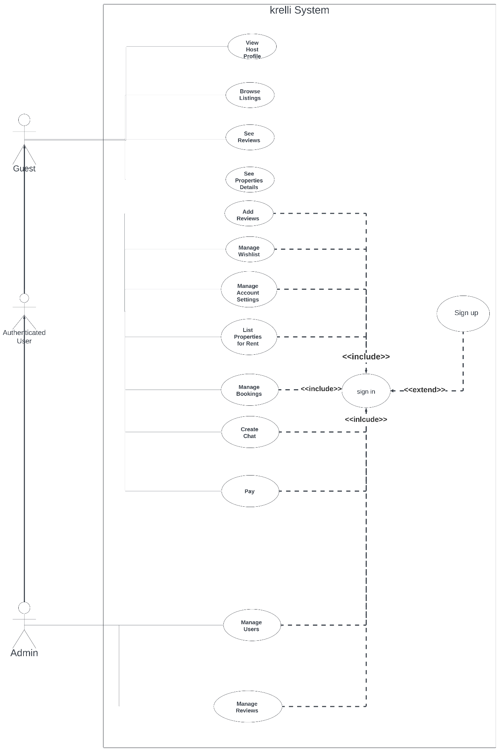

FIGURE: Use Case Diagram ([link for full picture](https://ibb.co/yfbrVS0))

**Here is the table that links each function to its actor:**

| **Use Case** | **Actor** |
| --- | --- |
| View Host Profile | Guest, AuthenticatedUser, Admin |
| Browse Listings | Guest, AuthenticatedUser, Admin |
| See Reviews | Guest, AuthenticatedUser, Admin |
| See Properties Details | Guest, AuthenticatedUser, Admin |
| Add Reviews | AuthenticatedUser, Admin |
| Manage Wishlist | AuthenticatedUser, Admin |
| Manage Account Settings | AuthenticatedUser, Admin |
| List Properties For Rent | AuthenticatedUser, Admin |
| Manage Bookings | AuthenticatedUser, Admin |
| Create Chat | AuthenticatedUser, Admin |
| Pay | AuthenticatedUser, Admin |
| Manage Users | Admin |
| Manage Reviews | Admin |

**2.6 Detailed Textual Description of Each Function**

To ensure a seamless and efficient experience for guests, authenticated users, and administrators, our rental app offers a range of tailored functionalities to enhance navigation, interaction, and management.

**2.6.1 Functionalities for Guests**

Guests on our rental platform benefit from the following functionalities:

**1. View Host Profile**

Guests can view the profiles of hosts to learn more about them and their properties.

**2. Browse Listings**

Guests have access to browse through various property listings available on the platform.

**3. SignIn**

Guests can sign in to their accounts to access additional features and personalized services If They already signed up.

**4. SignUp**

Guests can sign up for a new account to unlock more features and benefits on the platform.

**2.6.2 Functionalities for Authenticated Users**

Authenticated users, after logging into their accounts, can access additional functionalities:

**1. See Reviews**

Authenticated users can view reviews left by other users for properties and hosts.

**2. See Property Details**

Authenticated users can access detailed information about properties listed on the platform.

**3. Add Reviews**

Authenticated users can leave reviews for properties and hosts based on their experiences.

**4. Manage Wishlist**

Authenticated users can manage their wishlist of favorite properties for future reference.

**5. Manage Account Settings**

Authenticated users have the ability to manage their account settings, including personal information and preferences.

**6. List Properties For Rent**

Authenticated users can list their own properties for rent on the platform.

**7. Manage Bookings**

Authenticated users can manage their bookings, including viewing, editing, and cancelling reservations.

**8. Create Chat**

Authenticated users can initiate chats with hosts for inquiries or discussions regarding properties.

**9. Pay (For Bookings)**

Authenticated users can make payments specifically for bookings through the app.

**2.6.3 Functionalities for Administrators**

Administrators have access to the following functionalities to manage the platform effectively:

**1. Manage Users**

Administrators can manage user accounts, including creating, modifying, and deleting accounts as necessary.

**2. Manage Reviews**

Administrators can oversee and moderate user reviews for properties and hosts, ensuring compliance with platform policies and standards.

**1.9 - Conclusion:**

This chapter has provided an overview of our rental platform project, outlining our objectives and methodologies. We are poised to detail the functionalities to be implemented and the technologies chosen. Our focus is on creating a seamless rental experience for users in Algeria.

In the subsequent section, we will delve into the functionalities of the project. We will discuss the features and capabilities that will make our rental platform a comprehensive solution for landlords and tenants alike. Through collaboration and dedication, we aim to revolutionize the rental industry in Algeria.

***Chapter 2 :***

***Conception***

**2.1 Introduction**

Dans ce chapitre, nous allons explorer les fonctionnalités de notre système qui garantit une expérience utilisateur réussie et de répondre aux besoins des utilisateurs. L’objectif de ce chapitre est de fournir une vue d’ensemble complète des fonctionnalités de notre système, en mettant l’accent sur celles qui sont essentielles pour atteindre les objectifs du projet et améliorer la satisfaction de nos utilisateurs.

**2.2 Sequence diagram**

The sequence diagram describes how different objects interact in a system by showing the messages exchanged between them in a chronological sequence.

**2.2.1 Description**

A sequence diagram is an interaction diagram that details how operations are carried out: which

messages are sent and when they are sent. In the following, we will present some sequence diagrams related to the use cases presented, those that we deem likely to create ambiguities. Sequence diagrams are based on the Model-View-Controller model.

(MVC) :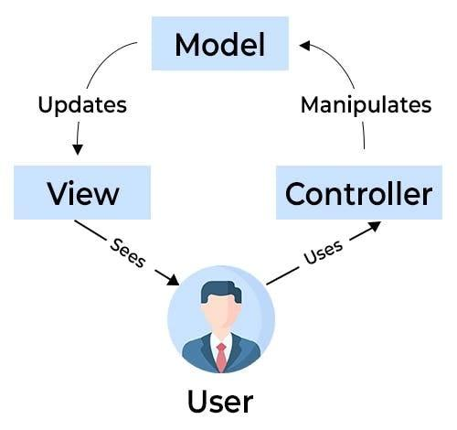

**2.2.2 *Sequence diagram of the system***

To present the workflow of the main functionalities of our system, authentication, and order placement, we have chosen the sequence diagram below.

FIGURE: Class Diagram ([link for full picture](https://ibb.co/qWFBnSs))

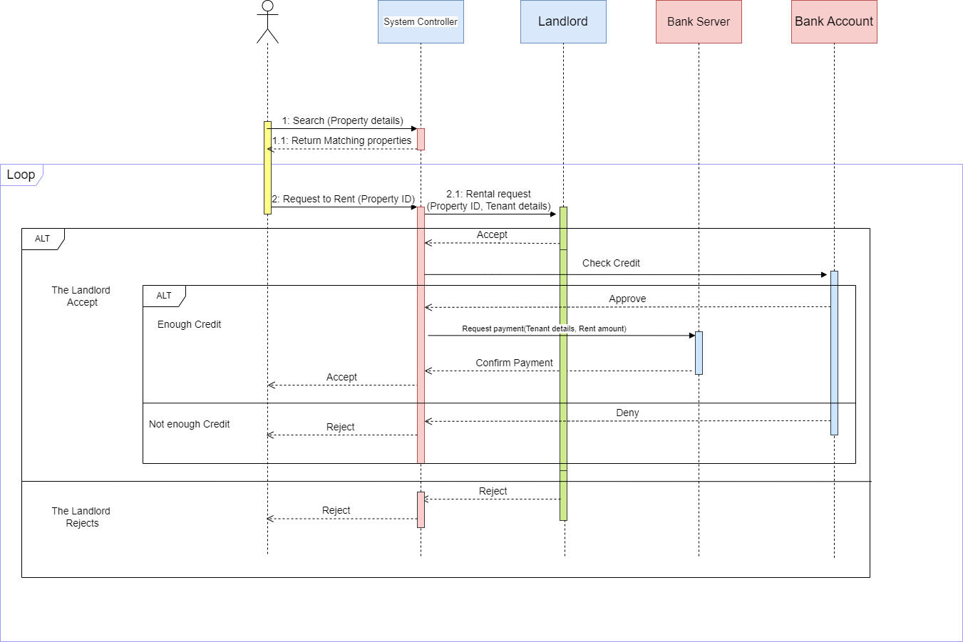

**2.3 Class diagram :**

The class diagram is used to describe the structure of a software system by identifying the different classes that compose it, their relationships, and

their Attributes.

**2.3.1 Description**

A UML class diagram describes the structures of objects and information used on the website, both internally and in communication with its users. It describes information without referring to a particular implementation. Its classes and relationships can be implemented in many ways, such as database tables.

**2.3.2 Class diagram of the system**

The following class diagram shows the different classes we have defined for our system to structure the design of our system :

FIGURE: Class Diagram ([link for full picture](https://ibb.co/mBVb2Lj))

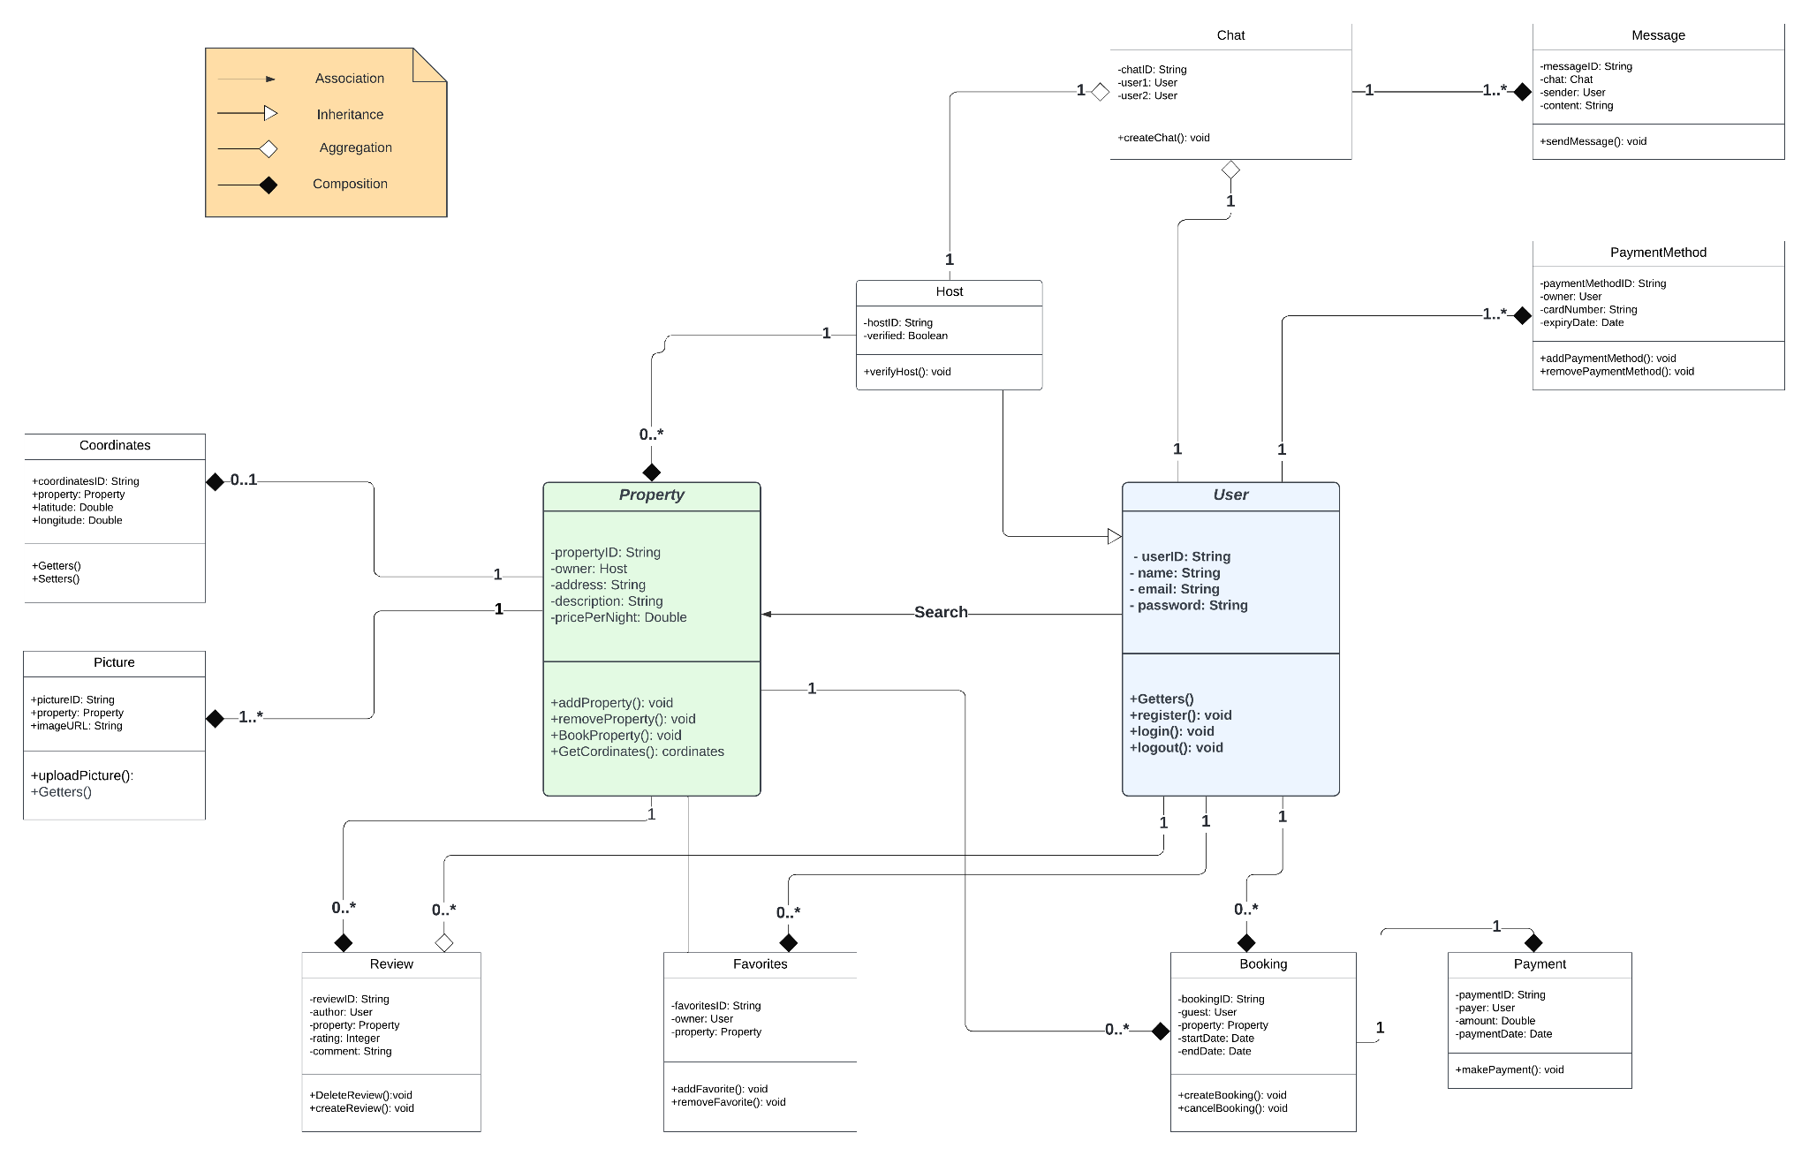

6

**2.4 Relational model of the database**

A relational database is a type of database that uses a tabular data structure to store and organize data. In a relational database, data is organized into tables, where each table represents an entity or a relationship between entities.

Each table in a relational database is composed of columns and rows. The columns represent the attributes or fields of the entity, while the rows represent the instances or records of the entity. Data is stored in these tables using primary keys and foreign keys to establish relationships between the tables.

For our website, here is the model we followed:

[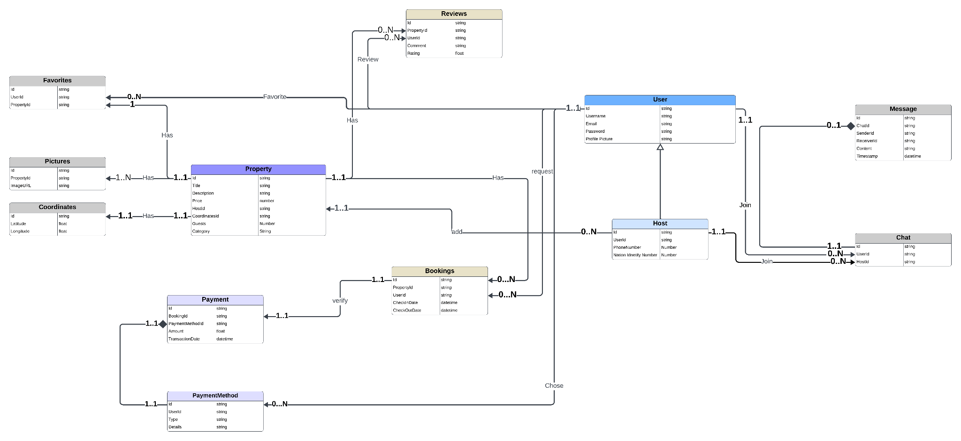](https://ibb.co/GvV6yF4)

FIGURE: Relational model of the database ([link for full picture](https://ibb.co/GvV6yF4))

**2.5 conclusion :**

In this chapter, we have presented the diagrams of the system, as well as the general scenario for each functionality, highlighting the processes and interactions between the different users. We have also provided the relational database model to complete our presentation of the system. To illustrate these elements, we have used UML diagrams, such as sequence and class diagrams. These diagrams have made it possible to visualize the processes and interactions described in the chapter.